Optimizing Telecom Operations with Segmentation and Churn Prediction

DANDU NEHA 21951A05B8 MOHAMMED AMEESHA 21951A05A4
MUKKA DHEERAJ 21955A0538
Page |I

Optimizing Telecom Operations with Segmentation and Churn Prediction

A Project Report Submitted in partial fulfillment of the
requirements for the award of the degree of

Bachelor of Technology in
Computer Science & Engineering by
Dandu Neha 21951A05B8 Mohammed Ameesha 21951A05A4 Mukka Dheeraj 21951A0538


Department of Computer Science Engineering

INSTITUTE OF AERONAUTICAL ENGINEERING
(Autonomous)
Dundigal, Hyderabad - 500 043, Telangana

APRIL 2024

© 2025,Dandu Neha, Mohammed Ameesha, Mukka Dheeraj.
All rights reserved

Page |II

DECLARATION

I certify that.
- The work contained in this report is original and has been done by me under the guidance of my supervisor(s).
- the work has not been submitted to any other Institute for any degree or diploma.
- I have followed the guidelines provided by the Institute in preparing the report.
- I have conformed to the norms and guidelines given in the Ethical Code of Conduct of the Institute.
- whenever I have used materials (data, theoretical analysis, figures, and text) from other sources, I have given due credit to them by citing them in the text of the report and giving their details in the references. Further, I have taken permission from the copyright owners of the sources, whenever necessary.

Place: Signature of the Student(s)

Date: Dandu Neha
Mohammed Ameesha
Mukka Dheeraj

Page |III

CERTIFICATE

This is to certify that the project report entitled “Optimizing Telecom Operations with Segmentation and Churn Prediction” submitted by Ms. Dandu Neha, Ms. Mohammed Ameesha, Mr. Mukka Dheeraj to the Institute of Aeronautical Engineering, Hyderabad, in partial in partial fulfillment of the requirements for the reward of the Degree Bachelor of Technology in Computer Science And Engineering is a bonafide record of work carried out by him/her under my/our guidance and supervision. In whole or in parts, the contents of this report have not been submitted to any other institutes for the award of any Degree.

Supervisor: Head of the Department:
Ms. K. Sangeeta Dr. C Madhusudhana Rao
Assistant Professor Professor and HOD, CSE

Date:

Page |IV

APPROVAL SHEET
This project report entitled Optimizing Telecom Operations with Segmentation and Churn Prediction by Ms. Dandu Neha, Ms. Mohammed Ameesha, Mr.Mukka Dheeraj is approved for the award of the Degree Bachelor of Technology in Computer Science and Engineering

Examiners Supervisor(s)
Ms. K. Sangeeta

Principal
Dr. L. V. Narasimha Prasad

Date : Place :

ACKNOWLEDGEMENT
The satisfaction that accompanies the successful completion of any task would be incomplete without the mention of the people who made it possible and whose constant guidance and encouragement crown all the efforts with success. I think out college management and respected Sri M. Rajashekar Reddy, Chairman, IARE, Dundigal for providing me with the necessary infrastructure to conduct the project work.
I express my sincere thanks to Dr. L. V. Narasimha Prasad, Professor and Principal who has been a great source of information for my work, and Dr. C. Madhusudhan Rao, Professor and Head, Department of CSE, for extending his support to carry on this project work.
I am especially thankful to our supervisor Dr.Y Mohana Roopa, Professor, Department of CSE, for her internal support and professionalism who helped me in shaping the project into a successful one. I take this opportunity to express my thanks to one and all who directly or indirectly helped me in bringing the effort to present form.

ABSTRACT

Keywords: Customer churn, churn prediction, telecom operations, machine learning, feature selection, customer segmentation, operational efficiency.

Client turnover is a significant issue and one of the top concerns for large businesses, particularly in the telecom sector, due to its direct impact on company profits. Companies are striving to develop methods to forecast probable outcomes to mitigate this impact. Identifying the factors contributing to customer churn is crucial for preventing it. Our work's key contribution is the creation of a churn prediction model that aids telecom providers in identifying customers who are most likely to churn. We analyze various scenarios of data analysis and present the results in graphical format. The model developed employs machine learning methods in a large data environment and introduces a novel approach for designing and selecting features. The datasets used to train, evaluate, and assess the algorithm include all customer data from previous months. We tested four different algorithms: Logistic Regression, Extreme Gradient Boosting (XGBoost), Gradient Boosted Machine (GBM) Trees, Random Forests, and Decision Trees. To increase the model's accuracy, the algorithms are trained with parameter tuning. This work focuses on optimizing telecom operations with segmentation and churn prediction, ultimately enhancing operational efficiency and customer retention.

CONTENTS
Title Page |  | I
Cover Page |  | II
Declaration |  | III
Certificate by Supervisor |  | IV
Approval Sheet |  | V
Acknowledgement |  | VI
Abstract |  | VII
Contents |  | VIII
List of Figures |  | IX
List of Abbreviations |  | X
Chapter 1 | Introduction | 1-8
 | 1.1 Problem Statement | 1-2
 | 1.2 Motivation | 2-3
 | 1.3 Objectives | 3-4
 | 1.4 Requirements Specification | 4-8
Chapter 2 | Literature Review | 9-12
Chapter 3 | Existing Mechanisms | 13-14
 | 3.1 Limitations of Existing Mechanisms | 14-15
Chapter 4 | Block chain Technology | 15-36
 | 4.1 Proposed system | 15-17
 | 4.2 Merits of Proposed System over Existing System | 17-20
 | 4.3 Methodology | 20-24
 | 4.4 System Architecture | 25-27
 | 4.5 Algorithms  4.6 Sample Code | 27-33  33-36
Chapter 5 | Results and Discussion | 37-40
Chapter 6 | Conclusion and Future Scope | 41-43
References
List of Publications

LIST OF FIGURES

FIG.NO | FIG.NAME | PG.NO
4.1.1 | Product Generation | 19
4.2.1 | System Architecture | 21
5.1 | E-commerce website | 31
5.2 | Private keys | 33
5.3 | Product Registration | 33
5.4 | QR Generation | 34
5.5 | Ganache Data | 34

LIST OF ABBREVIATIONS

GI | Geographical Indication
NLP | Natural Language Processing
GUI | Graphical User interface
PK | Private Keys
PR | Product Registration
DFD | Data Flow Diagram
URL | Uniform resource Locator
DB | Data Base

CHAPTER 1 INTRODUCTION

In the rapidly evolving landscape of digital commerce, the integration of blockchain technology has emerged as a transformative force. This work, titled "Blockchain Enabled E-Commerce for GI Products" explores the profound impact that blockchain can have on the marketing, distribution, and authenticity of Geographical Indication (GI) products.

In the age of digital commerce, ensuring the authenticity and traceability of products, particularly those with Geographical Indication (GI) tags, has become paramount. GI- tagged products, known for their unique origin and traditional production methods, face significant challenges in maintaining authenticity and consumer trust in online markets. To address these issues, we propose a Blockchain-enabled QR verification system designed to enhance the transparency, security, and trustworthiness of GI-tagged products in e- commerce platforms.

Our approach combines blockchain technology with QR code verification. Each GI-tagged product receives a unique QR code linked to its blockchain record, ensuring transparency and authenticity. Blockchain's immutable ledger records all transactions and movements, providing a tamper-proof history of the product from producer to consumer. This system enhances supply chain transparency, combats counterfeiting, and allows consumers to easily verify product authenticity with a simple scan.

PROBLEM STATEMENT
The e-commerce industry faces significant challenges in ensuring the authenticity, traceability, and security of products sold online, particularly in specialized sectors like GI (Geographical Indication) products. GI products, which are unique to a specific region and often have cultural, historical, or traditional significance, are particularly vulnerable to counterfeiting, fraud, and lack of transparency intheir supply chain. Consumers and businesses alike struggle to verify the authenticity of these products, leading to mistrust, loss of value, and difficulty in enforcing intellectual property rights. Currently, there is a

lack of a robust system for tracking and verifying the journey of GI products from their origin to the final consumer. Traditional methods of authentication, such as paperwork and manual certifications, are prone to errors, delays, and manipulation, resulting in a diminished reputationof GI products and economic losses for producers and sellers.
The problem, therefore, lies in creating a transparent, secure, and efficient way to track and verify GI products in the e-commerce space. A solution that can ensure the authenticity of these products, prevent counterfeiting, and offer consumers a trustable means to verify the origin and quality of the goods would not only protect the integrity of the products but also improve the confidence of consumers and increase the overall market value of GI products.

MOTIVATION
The motivation behind this project arises from the need to safeguard the authenticity and heritage of Geographical Indication (GI) products while promoting their reach in the global market. GI products, often linked to a specific region and traditional craftsmanship, represent the cultural and economic identity of communities. However, counterfeit products and lack of trust in supply chains have posed significant challenges to the sustainability of these goods. By integrating blockchain technology, this project seeks to provide a robust solution to these problems, ensuring transparency, traceability, and authenticity in the sale of GI products.
Blockchain technology, with its decentralized and immutable nature, is particularly well- suited for addressing issues of trust and verification in supply chains. By creating a unique QR code for each GI-tagged product, the project empowers consumers to verify the authenticity of their purchases instantly. This fosters trust between producers and consumers while discouraging counterfeit practices. Furthermore, a blockchain-enabled platform enhances traceability, ensuring that every transaction and movement of the product is recorded, thereby preserving its provenance and quality.
Another driving force behind the project is the desire to empower local artisans and producers who often lack the resources to compete in global markets. By creating an e- commerce platform specifically for GI products, the project aims to provide them with an opportunity to reach wider audiences, increasing their income and market visibility. The blockchain integration further adds value by assuring international buyers of the

authenticity and quality of the products, thus enhancing the competitiveness of these traditional goods.
This project also aligns with global efforts to promote sustainable development and preserve cultural heritage. By preventing counterfeiting and supporting genuine GI products, it contributes to the economic growth of regions dependent on these traditional goods. The initiative not only protects the rights of producers but also raises awareness about the cultural significance of GI products, encouraging ethical consumption among buyers.

OBJECTIVES

The project Blockchain-Enabled E-Commerce for GI Products aims to revolutionize the way Geographical Indication (GI) products are authenticated, marketed, and distributed by leveraging the power of blockchain technology. GI products hold significant cultural, economic, and social value, representing the unique heritage and traditional expertise of specific regions. However, counterfeit goods and inefficient supply chains often hinder the growth of these products. This project seeks to address these challenges by building a robust, transparent, and trustworthy ecosystem for GI products.
A key objective is to ensure authenticity and traceability for GI-tagged goods. Blockchain technology provides an immutable ledger that records every stage of a product’s lifecycle, from production to final sale. By integrating this capability into an e-commerce platform, the project enables consumers to verify the genuineness of products using unique blockchain-generated QR codes. This fosters trust among buyers and helps protect the intellectual property of artisans and producers.
Another goal is to promote the economic well-being of local communities involved in producing GI goods. By connecting producers directly to consumers through a digital platform, the project eliminates middlemen, ensuring fair compensation for artisans and farmers. Additionally, the platform’s global reach provides greater market exposure for these unique products, helping to preserve traditional crafts and skills.
The project also focuses on enhancing the overall user experience for both sellers and buyers. A seamless e-commerce interface, combined with blockchain’s security and

transparency, ensures smooth transactions while safeguarding user data. By integrating smart contracts, the system automates processes such as payments and order tracking, further streamlining operations.

REQUIREMENTS SPECIFICATIONS
    - SOFTWARE REQUIREMENTS

Blockchain Infrastructure
Blockchain Framework: Selection of a suitable blockchain platform like Ethereum, Hyperledger Fabric, or Polygon for implementing smart contracts and decentralized applications.
Smart Contracts: Code to automate and enforce business rules for transactions, product verification, and royalty distribution.
Node Software: Software to set up and manage nodes for blockchain network participation.

Database Management
Distributed Ledger: For storing transaction data securely and immutably across the blockchain.
Off-Chain Storage: Integration with traditional databases or decentralized storage solutions (e.g., IPFS, Filecoin) for storing large files like product images or detailed descriptions.

E-Commerce Platform
Web and Mobile Applications: Front-end platforms for customers and sellers to interact with the system. Frameworks like React, Vue.js, or Flutter can be used.
Backend Server: APIs and logic for handling user requests, integrated with blockchain for transaction execution (e.g., Node.js, Django).
Payment Gateways: Support for cryptocurrency payments (e.g., Bitcoin, Ethereum) and traditional methods (e.g., credit cards, UPI).

Authentication and Security

Digital Identity Management: Implementation of secure login and verification mechanisms for users using cryptographic keys or decentralized identity protocols.
Encryption Protocols: End-to-end encryption for data security during storage and transmission.

Traceability and Provenance
Product Tracking System: Tools to track the journey of GI products through supply chains using unique identifiers or QR codes linked to blockchain records.
Smart Labels: Integration of RFID, NFC, or QR code systems with blockchain for transparency and consumer verification.

Analytics and Reporting
Data Analytics Tools: Real-time insights into sales, product demand, and blockchain activity using analytics frameworks.
Monitoring Dashboards: Dashboards for stakeholders to monitor product authenticity, trade volumes, and user activities.

Regulatory and Compliance Tools
Compliance Management: Tools to ensure adherence to GI regulations, intellectual property laws, and consumer protection

HARDWARE REQUIREMENTS
- Servers:
High-performance processors for running blockchain nodes and smart contracts. Sufficient RAM (16GB or more) for efficient data processing.
Redundant power supplies for high availability.

- Storage:
Scalable storage systems (e.g., SSDs) for storing blockchain ledger and transaction data.
Backup storage solutions for disaster recovery.

- Networking:
High-speed internet connectivity for reliable node communication. Firewalls and network security hardware to prevent unauthorized access.

- End-User Devices:
Smartphones, tablets, or desktops with web access.
Hardware compatibility with e-commerce applications (e.g., NFC for secure payments).

- Security Enhancements:
Hardware Security Modules (HSMs) for managing cryptographic keys. Cryptographic processors for secure transaction signing.

- Scalability & Redundancy:
Load balancers to distribute traffic.
Clustered servers for scalability and fault tolerance.

- Disaster Recovery:
Backup power systems (UPS) for uninterrupted operation. Remote backup storage for data redundancy.

SYSTEM INTERFACE

- API for Product Registration: A secure API to allow authorized producers to register products and interact with the system.
- Consumer Verification App/Website: An interface for consumers to scan QR codes, retrieve product information, and verify authenticity. This could be a mobile app or a web application depending on the project scope.

- Blockchain Network Interface: The system will require libraries or APIs to interact with the chosen blockchain network for data storage and retrieval.

DATA REQUIREMENTS

- Product and GI Certification Data
- Description of the Product: Detailed specifications of the GI product, including its unique attributes.
- GI Certification Details: Proof of certification, including registration numbers and issuing authority details.
- Origin Data: Information about the region of production, geographical boundaries, and compliance with GI standards.
- Producer Information: Verified details of authorized producers or cooperatives.

- Supply Chain and Traceability Data
- Raw Material Sources: Information on the origin of raw materials, if applicable.
- Production Process: Step-by-step documentation of how the product was created, ensuring compliance with GI regulations.
- Logistics Information: Data on storage, transportation, and handling to track the product through the supply chain.
- Proof of Authenticity: Digital records or unique identifiers like QR codes, RFID tags, or blockchain tokens.

- Transactional Data
- Smart Contract Details: Pre-defined conditions encoded into blockchain to automate payments and dispute resolutions.
- Purchase Records: Details of buyers, transaction history, and payment proofs.
- Inventory Management: Data on stock levels, restocking timelines, and product availability.

- Consumer-Focused Data
- Product Verification: Mechanism for consumers to verify authenticity using blockchain (e.g., scanning a QR code).
- Educational Content: Information about the product’s cultural and geographical significance.

- Feedback and Reviews: Consumer feedback loop stored immutably to enhance trust and quality.

CHAPTER 2 LITERATURE SURVEY

Blockchain technology, originally conceptualized as the underlying structure for Bitcoin, has evolved into a revolutionary framework with applications far beyond digital currencies. This paper explores the fundamental principles of blockchain, including its decentralized ledger system, cryptographic security, and consensus mechanisms. We examine the architecture of blockchain, highlighting its components such as blocks, chains, nodes, and miners, and how they interconnect to ensure data integrity and transparency.
Additionally, we delve into various consensus algorithms like Proof of Work (PoW), Proof of Stake (PoS), and newer models such as Delegated Proof of Stake (DPoS) and Practical Byzantine Fault Tolerance (PBFT). The paper also investigates smart contracts and their role in automating and securing transactions on blockchain network.

Smart contracts are set of instructions which are stored on a blockchain. These instructions will be executed automatically without middle-man interaction. Smart contracts in the blockchain allows the transactions and contracts to be executed across undesignated nodes without an interaction of central system or external enforcement. The transactions are transparent, traceable and irreversible. In blockchain all the data stored are secure and immutable. So blockchain would be the suitable environment for smart contracts. Smart contract data is encrypted and placed in a distributed ledger, which means the information stored in the blocks cannot be deleted or modified. There are many blockchain platforms supporting smart contracts. This paper explores the information about various smart contract platforms and its features.

The supply chain plays an important role in daily life, and its traceability ensures product quality and safety. Therefore, an efficient and reliable solution to improve supply chain traceability is urgently needed. Because of its advantages of being decentralized, tamper-

proof, and transparent, the emerging blockchain technology should address the problems of unreliable data and low tracking efficiency in traditional traceability systems. This paper explores blockchain-based supply chain traceability solutions, reviews recent research, and identifies challenges.
First, the basics of blockchain are introduced, and the traditional traceability model and stakeholder needs are described. Then, the existing publications and enterprise applications are reviewed and analyzed in detail. Using blockchain is found to bring many benefits. It is also found that the current academic solutions are mostly based on mainstream blockchain platforms and lack specific and comprehensive evaluation. Finally, challenges and future research questions are discussed. Future research could focus on designing targeted consensus mechanisms, designing appropriate access control, the role of regulators in the supply chain, etc. This review shows that blockchain has great potential to address traceability issues, but many challenges remain. Key words: blockchain; supply chain; traceability.

Identity Management System (IDMS) refers to how users or individuals are identified and authorized to use organizational systems and services. Since traditional identity management and authentication systems rely heavily on a trusted central authority, they cannot mitigate the effects of single points of failure. As a decentralized and distributed public ledger in a peer-to-peer (P2P) network, Blockchain (BC) technology has garnered a considerable amount of attention in the field of IDMS in recent years. Through Self- Sovereign Identity (SSI), users can have full authority over their digital identity.

Successful implementation of a BC-based IDMS can significantly increase the degree of privacy and security of a user’s SSI. However, the integration of BC-based IMDS to provide a user with SSI is still an unorganized area of research in its early stages of development. This article presents an extensive literature review of state-of-the-art academic publications as well as commercial market offerings regarding the applicability of BC-based SSI solutions. It also provides a detailed preliminary regarding the building blocks of blockchain technology and a progressive roadmap of IDMS solutions. In order to develop an effective BC-based IDMS solution that focuses on securing a user’s SSI, this article outline five essential components of a BC-based IDMS: authentication,

integrity, privacy, trust, and simplicity. Furthermore, we perform a security analysis that outlines several types of adversarial threats that can cause potential damage to the BC- based IDMS. We identify and discuss associated issues and challenges by analyzing several notable BC-based IDMS solutions in academic literature. We also highlight potential research gaps and provide future research scope.

Electronic commerce or e-commerce includes the service and good exchange through electronic support like the Internet. It plays a crucial role in today’s business and users’ experience. Also, e-commerce platforms produce a vast amount of information. So, Recommender Systems (RSs) are a solution to overcome the information overload problem. They provide personalized recommendations to improve user satisfaction.
present article illustrates a comprehensive and Systematic Literature Review (SLR) regarding the papers published in the field of e-commerce recommender systems. We reviewed the selected papers to identify the gaps and significant issues of the RSs’ traditional methods, which guide the researchers to do future work. So, we provided the traditional techniques, challenges, and open issues concerning traditional methods of the field of review based on the selected papers. This review includes five categories of the RSs’ algorithms, including Content-Based Filtering (CBF), Collaborative Filtering (CF), Demographic Based Filtering (DBF), hybrid filtering, and Knowledge-Based Filtering (KBF). Also, the salient points of each selected paper are briefly reported. The publication time of the selected papers ranged from 2008 to 2019. Also, we provided a comparison table of important issues of the selected papers as well as the tables of advantages and disadvantages. Moreover, we provided a comparative table of metrics and review issues for the selected papers. And finally, the conclusions can, to a great extent, provide valuable guidelines for future studies.
INDEX TERMS: Recommendation systems, electronic commerce, personalization, review

CHAPTER 3 EXISTING MECHANISMS

This research proposes a new method for secure data sharing in cross-border e- commerce that combines blockchain and cryptography.

Blockchain Integration with E-Commerce Platforms
  - Tracking and Authenticity: Blockchain provides tamper-proof records of GI product origins and ensures authenticity, preventing counterfeits.
  - Smart Contracts: Automated execution of transactions and enforcement of agreements between buyers and sellers.
  - Transparency: All stakeholders, including farmers, manufacturers, and consumers, can access transparent information about the supply chain.

Supply Chain Management
  - Traceability: Enables real-time tracking of GI products from production to delivery.
  - Decentralized Ledger: Offers a distributed, secure record of every transaction, fostering trust among stakeholders.
  - Improved Quality Control: Records on the blockchain help monitor and verify product standards throughout the supply chain.

Certification and Authentication
  - Immutable Records: Blockchain ensures secure and permanent records of GI certifications, reducing the risk of forgery.
  - QR Codes and RFID Tags: Consumers can scan these to verify the authenticity of GI products.

Payment Systems
  - Cryptocurrency Payments: Some platforms accept blockchain-based payments, enabling secure and decentralized transactions.
  - Reduced Intermediaries: Direct payments between buyers and sellers reduce costs and improve efficiency.

Consumer Engagement

  - Enhanced Trust: Blockchain’s transparency increases consumer confidence in GI product authenticity.
  - Digital Provenance: Storytelling around the origin and heritage of GI products enhances brand value.

Government and Institutional Support
  - National and Regional Blockchain Initiatives: Governments are integrating blockchain technology to support GI product marketing and distribution.
  - Public-Private Partnerships: Collaboration between government, e-commerce platforms, and blockchain providers enhances adoption.

Challenges and Solutions
  - Scalability Issues: Overcoming high transaction costs and time delays with optimized blockchain systems like Layer 2 solutions.
  - Awareness and Training: Conducting awareness programs for GI producers and consumers about blockchain’s benefits.
  - Policy Frameworks: Establishing clear guidelines and regulations for blockchain implementation in GI e-commerce.

Overall, the research explores using blockchain and cryptography to create a secure and efficient system for data sharing in cross-border e-commerce.

LIMITATIONS OF EXISTING MECHANISMS
The existing systems for e-commerce of GI (Geographical Indication) products, particularly those not leveraging blockchain technology, have several demerits. Here are some of the main challenges and limitations:

Lack of Transparency:

Traditional systems often lack the transparency needed to verify the authenticity of GI products. Consumers may find it difficult to trust the provenance and quality claims.

Counterfeiting and Fraud:

The absence of a robust verification system makes it easier for counterfeit products to enter the market, undermining the value of genuine GI products and harming the reputation of producers.

    - Lack of Comprehensive Authentication:

      - Many systems do not authenticate users adequately, which can lead to unauthorized access and tampering.
    - Inadequate Traceability:

      - The ability to trace documents and verify their authenticity is limited, which is a significant drawback for GI-tagged products.
    - Synchronization Challenges:

      - Without proper file synchronization, maintaining consistent and up-to- date records across different platforms is challenging.
    - Scalability Concerns:

      - Not all existing systems are scalable, which can hinder their ability to manage increasing volumes of data and transactions.

By addressing these shortcomings, the proposed Blockchain-enabled QR verification system aims to enhance the security, reliability, and traceability of GI-tagged products in e-commerce.

CHAPTER 4
BLOCK CHAIN TECHNOLOGY

PROPOSED SYSTEM
This system aims to ensure the authenticity and traceability of GI-tagged products sold online using QR codes and blockchain technology.
    - Product Registration: Each GI-tagged product receives a unique identifier linked to its specific details (origin, production methods, etc.). This information is registered on a blockchain.
    - QR Code Generation: A unique QR code is generated that directly links to the product's record on the blockchain. This code is printed on the product's packaging.
    - Consumer Verification Process:
      - Customers scan the QR code on a GI-tagged product using their smartphone camera app.
      - The scan triggers an interaction with a blockchain verification app or website.
      - The app/website retrieves the product's information from the blockchain using the unique identifier embedded in the QR code.
      - Consumers are presented with details about the product's origin, production methods, and potentially even its journey through the supply chain (depending on the level of detail stored on the blockchain).

The proposed system leverages blockchain technology to create a decentralized and secure e-commerce platform for the sale of Geographical Indication (GI) products. This platform ensures the authenticity, traceability, and transparency of each product, making it easier for consumers to verify the origins and quality of GI products. Sellers, who are verified by authorized authorities, can register their GI products, linking them to the blockchain, where every transaction, including product details, payments, and delivery, is securely recorded. Smart contracts automate key functions like payments, order fulfillment, and dispute resolution, while the use of cryptocurrencies allows for seamless, global transactions. The system also supports a feedback mechanism where buyers can leave reviews, stored

immutably on the blockchain, to further enhance trust. By enabling secure, transparent, and efficient transactions, the proposed system benefits both producers and consumers, ensuring the protection of regional heritage and fostering the growth of GI products in the global marketplace.

Key Features of the Proposed System:
- Product Registration and Verification:
  - Sellers upload product details, including certifications and regional origin, to the blockchain.
  - A third-party verification process confirms the authenticity of the GI certification and records it immutably on the blockchain.
- Smart Contracts for Transactions:
  - Payments are secured and automatically processed using smart contracts, ensuring that funds are only released when the product is delivered and confirmed by the buyer.
- Decentralized and Transparent Marketplace:
  - The platform operates on a decentralized blockchain network, providing transparent and verifiable records of every product's journey from origin to delivery.
- Immutable Product History and Traceability:
  - Each GI product has a unique identifier that traces its journey through the supply chain, giving buyers the ability to verify the product’s authenticity and quality in real time.
- Dispute Resolution Mechanism:
  - If disputes arise between buyers and sellers, blockchain records provide transparent evidence for resolving conflicts, reducing the need for intermediaries.
- Cryptocurrency Payments:
  - The platform supports cryptocurrency payments, offering secure and fast transactions across global borders, making it easier for international buyers to purchase GI products.
- Review and Feedback System:

  - Buyers can leave reviews and feedback, which are stored on the blockchain, ensuring transparency and an immutable history of buyer satisfaction.
- Support for Local Producers:
  - By verifying the authenticity of GI products, the platform helps protect local artisans and farmers, enhancing their reputation and market reach while preventing counterfeiting.
- Supply Chain Transparency:
  - The system enables complete traceability of each product, from raw material sourcing to delivery, ensuring that consumers can verify every stage of the product’s journey.

MERITS OF PROPOSED SYSTEM OVER EXSISTING SYSTEM

The proposed blockchain-enabled e-commerce platform for Geographical Indication (GI) products offers several advantages over traditional e-commerce systems. Existing systems often struggle with issues such as product authenticity, lack of transparency, fraud, and inefficiencies in cross-border transactions. Blockchain’s decentralized nature, along with features like immutability, traceability, and automation, addresses these challenges effectively. The proposed system ensures that each product’s journey is transparent and verifiable, empowering both buyers and sellers with accurate information about the origin, quality, and authenticity of GI products. Moreover, the automation of processes like payment and dispute resolution reduces manual intervention, making the system more efficient and less prone to errors. By leveraging blockchain, the system also ensures that product history and consumer feedback are securely stored and cannot be tampered with, offering a higher level of trust than existing systems.
Key Merits of the Proposed System:

- Enhanced Transparency and Traceability:

  - Proposed System: Provides full traceability of the product from its origin to the point of delivery, ensuring that consumers can verify the authenticity of each GI product.

  - Existing System: Often lacks transparency, making it difficult to verify the origin and authenticity of products, leading to issues with counterfeit goods.
- Immutability of Records:

  - Proposed System: All product and transaction records are securely stored on the blockchain, ensuring that once data is entered, it cannot be altered or deleted.
  - Existing System: Traditional systems may be susceptible to data manipulation or errors, leading to trust issues between buyers and sellers.
- Reduction of Fraud and Counterfeiting:

  - Proposed System: The blockchain ensures the authenticity of GI products through verified and immutable certificates, preventing fraud and counterfeiting.
  - Existing System: Counterfeiting and fraud are common problems in e- commerce, especially with GI products, as there are often no reliable verification mechanisms.
- Smart Contract Automation:

  - Proposed System: Smart contracts automate key processes such as payments, order fulfillment, and dispute resolution, reducing the need for intermediaries and ensuring that terms are met automatically.
  - Existing System: These processes are typically manual, leading to delays, errors, and higher operational costs due to reliance on intermediaries.
- Global and Secure Payments:

  - Proposed System: The platform supports cryptocurrency payments, offering a faster, secure, and low-cost method for international transactions.

  - Existing System: Traditional systems often involve multiple intermediaries, leading to delays, high transaction fees, and difficulties in cross-border payments.
- Consumer Trust and Confidence:

  - Proposed System: Blockchain’s transparency and immutability, combined with a secure review system, foster trust between consumers and sellers, as feedback and product histories are tamper-proof.
  - Existing System: Trust is often a challenge in traditional e-commerce, as reviews can be manipulated, and there is a lack of transparency about product origins.
- Efficient Dispute Resolution:

  - Proposed System: Dispute resolution is streamlined and transparent, with blockchain records providing clear evidence to resolve conflicts fairly and quickly.
  - Existing System: Dispute resolution can be slow and cumbersome, with third-party intermediaries involved and no guaranteed transparency in handling complaints.
- Protection for Local Producers:

  - Proposed System: GI products are authenticated and protected on the blockchain, which helps local artisans and producers prevent exploitation and ensure fair trade.
  - Existing System: Local producers often lack proper protection, leading to issues with exploitation, counterfeiting, and unfair competition.
- Reduced Operational Costs:

  - Proposed System: The automation of processes, removal of intermediaries, and reduced fraud help lower operational costs for both sellers and platform providers.
  - Existing System: Traditional systems involve many intermediaries, increasing costs and inefficiencies, which can result in higher prices for consumers and lower profit margins for sellers.
- Scalability and Future-proofing:

  - Proposed System: The decentralized nature of blockchain allows for scalability and adaptability, ensuring that the system can grow with increasing demand for GI products.
  - Existing System: Traditional systems often struggle to scale effectively as they depend on centralized databases, which can become bottlenecks.

METHODOLOGY
- Product Registration:

  - Producers of GI-tagged products register each item with a designated authority.
  - During registration, a unique identifier is assigned to the product, capturing details like origin, production methods, and other relevant information.
  - This unique identifier, along with the product details, is then registered on a blockchain network.
- QR Code Generation:

  - A unique QR code is generated for each GI-tagged product.

  - This QR code directly links to the product's specific record stored on the blockchain.

  - The generated QR code is then printed on the product's packaging, label, or other secure location.
- Consumer Verification Process:

  - Consumers who wish to verify a GI-tagged product use a blockchain verification app or website.
  - The app/website features a QR code scanner.

  - Consumers scan the unique QR code on the product using their smartphone camera app.
  - The scanner within the verification app/website retrieves the product's unique identifier embedded in the QR code.
  - Using this identifier, the app/website interacts with the blockchain network to fetch the corresponding product record.
- Information Display:

  - Once retrieved, the app/website displays detailed information about the product to the consumer.
  - This information typically includes the product's origin, traditional production methods, and potentially even its journey through the supply chain (depending on the level of detail stored on the blockchain).
- Integration with E-commerce Platforms:

  - Integrate the verification system with popular e-commerce platforms.

  - This would allow consumers to directly scan product QR codes within the shopping platform, streamlining the verification process and boosting trust during online purchases.
- Scalability Solutions:

  - Explore blockchain scalability solutions like sharding or sidechains to accommodate the potential growth in the number of registered GI-tagged products.
  - This ensures efficient data management as the system scales.

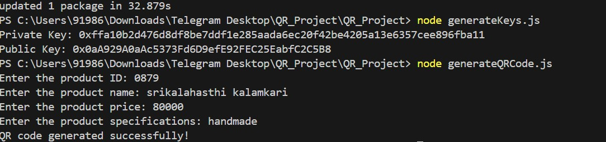

Fig 4.1.1 Product Generation

Implementation Steps:

- Install Truffle:
  - Truffle is a popular development framework for Ethereum. Open a terminal or command prompt and run the following command to install Truffle globally:
  - npm install -g truffle
- Start Ganache: Launch the Ganache application you installed. Ganache will provide you with a local Ethereum blockchain network for development purposes.
  - Make a note of the network settings, such as the RPC server address and port number, as you will need them later.
- Generate a Private/Public Key Pair

  - Create a New Ethereum Project: Choose a directory where you want to create your Ethereum project. Open a terminal or command prompt and navigate to the chosen directory.
  - Run the following command to create a new Truffle project:
  - truffle init
- Generate a Private Key:
  - Ethereum uses the concept of an Ethereum account, which includes a private key and a public key.
  - To generate a private key, you can use tools like web3.js or ethers.js. We will use ethers.js in this example.
  - In your project directory, run the following command to install ethers.js:
  - npm install ethers
- Generate the Private/Public Key Pair:
  - Create a new file called generateKeys.js in your project directory. Open generateKeys.js in a text editor and write the code to generate the Private/Public Key Pair.
- Run the Key Generation Code:
  - Save the changes to generateKeys.js.
  - In the terminal, navigate to your project directory.
  - Run the following command to execute the key generation code:
  - node generateKeys.js
- Retrieve the Private/Public Key Pair:
  - After executing the code, you will see the generated private and public keys printed in the terminal. Make a note of both the private key and the public key, as you will need them in the next steps.

These steps cover the installation and configuration of the Ethereum blockchain platform using Ganache and Truffle, as well as generating a private/public key pair using ethers.js. With the private and public keys, we can proceed to integrate them into our code or use them for Ethereum account management.

SYSTEM ARCHITECTURE
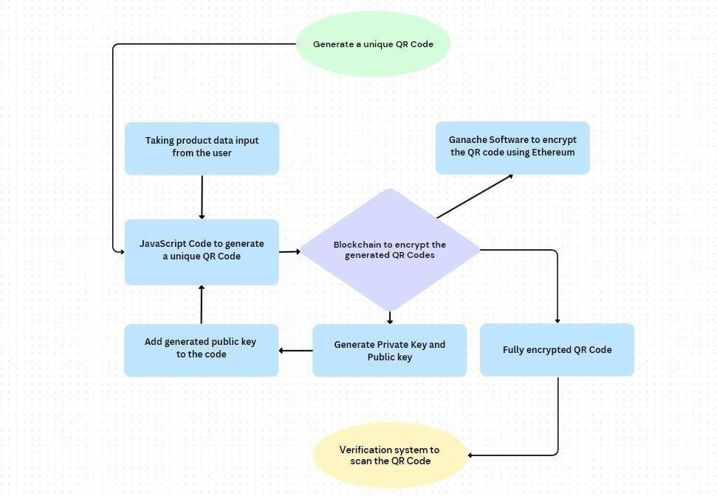

Fig.4.2.1 System architecture
To implement the Blockchain-Encrypted QR Labels we need to follow the below given steps:

- We need to generate a unique QR code for each product or service being offered.
- In the next step, we use blockchain technology to encrypt the QR code and ensure that it cannot be tampered with or duplicated.
- And then implementing a verification system that can scan the QR code and check its authenticity using blockchain technology.
- We should also provide customers with access to the verification system and instructions on how to use it.

- At last, encourage customers to scan the QR code to verify the authenticity of the product or service they are interested in.

Components:
  - Unique QR codes linked to product information stored on a blockchain.
  - Verification app/website for consumers to scan QR codes and retrieve product details.

Process:
  - Product registration on blockchain with unique identifier and details.
  - QR code generation linked to the product's blockchain record.
  - Consumers scan QR code using a verification app.
  - App retrieves product information from the blockchain using the unique identifier.
  - Consumers view details about the product's origin, production methods, etc.

Functional Requirements:

- User Management

- Product Management

- Blockchain Integration

- Product Registration

- Data Storage on Blockchain

- QR Code Generation

- Product Packaging and Labeling

- Consumer Verification App/Website

- Blockchain Data Retrieval

- Information Display

- Security Measures

Non-Functional Requirements:

- performance

- Reliability

- Security

- Privacy

- Usability

- Interoperability

- Maintainability

- Flexibility

- Compliance

- Localization

ALGORITHM:
Step 1: User Registration and Authentication
- Input: User information (name, email, contact details)
- Process:
  - Users (buyers, sellers, and administrators) create accounts on the platform.
  - They must authenticate their identities via email verification or a two-factor authentication (2FA) system to prevent fraud.

  - Upon successful authentication, a unique cryptographic key pair (private and public keys) is generated for each user, stored securely.
- Output: A verified user account with a private-public key pair.

Step 2: Product Registration (by Sellers)
- Input: Product details (name, description, region of origin, images, certifications, etc.)
- Process:
  - The seller uploads the product information onto the blockchain-enabled platform.
  - A smart contract is created for the GI product that stores relevant product data such as:
    - GI certificate number
    - Date of origin verification
    - Quality certificates
    - Seller information
  - Blockchain nodes store the product data immutably.
  - Product information undergoes a verification process, potentially through a third-party authentication service, to ensure its GI authenticity.
- Output: A unique product identifier (PID) linked to the blockchain entry.

Step 3: Verification of GI Authenticity
- Input: Product details (for verification), Seller’s GI certificate
- Process:
  - A verification node (trusted authority) checks the GI certificate's authenticity and cross-references it with a central database or another authoritative source.
  - If the product is authentic, a transaction is recorded on the blockchain confirming its
GI status.
  - If the verification fails, the product is flagged for review, and the seller is notified.

- Output: A verified or rejected GI product status, stored on the blockchain.

Step 4: Product Listing and Search (by Buyers)
- Input: Search parameters (product name, region, price range, etc.)
- Process:
  - The buyer searches for GI products on the platform using various filters (region, product type, price, etc.).
  - The platform queries the blockchain for relevant product data using the product's unique identifier (PID).
  - The system fetches all necessary details about the GI product (product name, description, verification status, seller info).
  - The results are displayed to the buyer with product authenticity information from the blockchain.
- Output: A list of verified GI products for the buyer to choose from.

Step 5: Order Placement (by Buyers)
- Input: Selected product, buyer details, shipping address, payment method
- Process:
  - The buyer selects a GI product and initiates the order placement.
  - The buyer submits their shipping and payment details, and the order is recorded as a transaction on the blockchain.
  - A smart contract is created to handle the payment and delivery terms:
    - Smart contracts ensure that funds are released to the seller only once the product has been delivered.
    - Shipping information is linked to the blockchain for transparency and tracking.
- Output: An order transaction with a unique order ID and blockchain record.

Step 6: Payment and Settlement
- Input: Payment details (cryptocurrency, fiat, etc.)
- Process:
  - The buyer proceeds to make payment for the GI product.

  - The platform supports payment via cryptocurrency or fiat (via payment gateway integration).
  - The payment is processed securely, and a transaction record is created on the blockchain to confirm the payment.
  - The payment amount is held in escrow by a smart contract until the product is delivered and verified by the buyer.
- Output: A completed payment transaction stored on the blockchain.

Step 7: Product Delivery and Verification
- Input: Shipping details, delivery status
- Process:
  - Once the product is shipped, the seller provides shipping details (tracking number, courier).
  - The buyer receives notifications about the product's status via the platform.
  - Upon delivery, the buyer inspects the product and confirms the delivery on the blockchain platform.
  - If the product matches the description and is authenticated, the payment is released to the seller from escrow.
- Output: Delivery confirmation, funds released to the seller.

Step 8: Review and Feedback
- Input: Product quality feedback, delivery experience
- Process:
  - The buyer leaves a review based on the product's authenticity, quality, and shipping experience.
  - Reviews are stored on the blockchain, making them immutable and transparent.
  - Both the buyer and seller can leave feedback to promote trust within the platform.
- Output: An immutable review and rating for the product and seller, which can be used by future buyers.

Step 9: Dispute Resolution (if required)
- Input: Dispute details (delivery issues, product quality)
- Process:
  - In case of a dispute between the buyer and the seller (e.g., product not matching the description, damaged product), the platform allows for resolution.
  - A neutral third-party mediator reviews the evidence (e.g., photos, transaction logs) stored on the blockchain.
  - The mediator can use the blockchain records to issue a final ruling, and the smart contract may refund the buyer or release funds to the seller, depending on the outcome.
- Output: Dispute resolution outcome stored on the blockchain.

Step 10: Product Tracking and Transparency
- Input: Shipment tracking number, product ID
- Process:
  - The entire supply chain, from product creation to delivery, is tracked using blockchain, providing a transparent history.
  - Buyers can view the journey of the GI product, ensuring its authenticity and origin.
  - Any changes in ownership, custody, or status are recorded in real-time on the blockchain.
- Output: A traceable product history visible to all users.

Product Generation:
def register_product(product_name, origin, production_method, additional_details):
# Generate unique identifier (UID) uid = generate_unique_id()
# Create data record data_record = {

"uid": uid,
"product_name": product_name, "origin": origin,
"production_method": production_method, "additional_details": additional_details
}
# Hashing the data record data_hash = hash_data(data_record)
# Interact with blockchain (pseudocode) send_transaction_to_blockchain(data_record, data_hash) # Generate QR code (pseudocode)
qr_code_data = generate_qr_code_data(uid) generate_qr_code(qr_code_data)
return uid

Consumer Verification Process (JavaScript):

async function verifyProduct(qrCodeData) {
// Extract UID from QR code data
const uid = extract_uid_from_qr_code(qrCodeData);
// Interact with blockchain (pseudocode)
const productData = retrieve_product_data_from_blockchain(uid);
// Verify Merkle Tree proof (pseudocode)
const isValid = verify_merkle_proof(productData.merkleProof); if (isValid) {
return productData;
} else {
throw new Error("Product data could not be verified.");
}
}
// Helper functions (not shown here): extract_uid_from_qr_code(), retrieve_product_data_from_blockchain(), verify_merkle_proof()

Blockchain:

// Product Registration send_transaction_to_blockchain(data_record, data_hash) {
// Simulate interaction with a chosen blockchain platform (e.g., Ethereum) to add the data record and its hash.
}
// Consumer Verification retrieve_product_data_from_blockchain(uid) {
// Simulate retrieving the product data record from the blockchain based on the provided UID.
// Include retrieval of the Merkle proof for efficient data verification.
}

SAMPLE CODE:
const QRCode = require('qrcode');
const publicKey = '0xb2da5E1AA02407F30559f4264966a2bAEff81373'; const Jimp = require('jimp');
const readline = require('readline');

async function generateQRCode() {
const rl = readline.createInterface({ input: process.stdin, output: process.stdout
});

const productId = await new Promise((resolve) => { rl.question('Enter the product ID: ', (answer) => {
resolve(answer);
});
});

const productName = await new Promise((resolve) => { rl.question('Enter the product name: ', (answer) => {

resolve(answer);
});
});

const productPrice = await new Promise((resolve) => { rl.question('Enter the product price: ', (answer) => {
resolve(answer);
});
});

const productSpecifications = await new Promise((resolve) => { rl.question('Enter the product specifications: ', (answer) => { resolve(answer);
});
});
rl.close(); const qrData = {
id: productId, name: productName, price: productPrice,
specifications: productSpecifications,
};
const qrCodeString = JSON.stringify(qrData); QRCode.toFile('qr_code.png', qrCodeString, { color: {
dark: '#000000',
light: '#ffffff',
},
},async (err) => { if (err) {
console.error('Error generating QR code:', err); return;
}

// Open the generated QR code image using Jimp const qrCodeImage = await Jimp.read('qr_code.png');

// Open the verified tick mark image using Jimp
const tickImage = await Jimp.read('verified_tick.png'); // Replace with the path to the verified tick mark image file

// Resize the tick mark image to fit within the QR code tickImage.resize(qrCodeImage.bitmap.width * 0.2,
qrCodeImage.bitmap.width * 0.2);

// Calculate the position for the tick mark overlay
const x = qrCodeImage.bitmap.width - tickImage.bitmap.width - 10; const y = qrCodeImage.bitmap.height - tickImage.bitmap.height - 10;

// Compose the QR code image and the tick mark overlay qrCodeImage.composite(tickImage, x, y);

// Save the final QR code image with the tick mark overlay qrCodeImage.write('qr_code_with_tick.png');

});
console.log('QR code generated successfully!');
}

generateQRCode();

KEYS ACCESS
const ethers = require('ethers');

// Generate a new random private key
const privateKey = ethers.Wallet.createRandom().privateKey; console.log('Private Key:', privateKey);

// Derive the public key from the private key const wallet = new ethers.Wallet(privateKey); const publicKey = wallet.address; console.log('Public Key:', publicKey

CHAPTER 5 RESULTS AND DISCUSSION

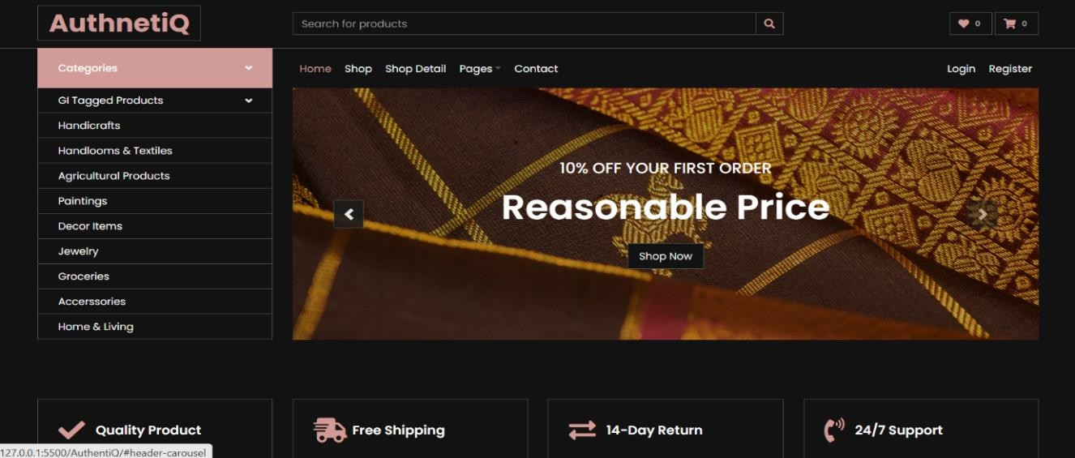
Fig 5.1 E-Commerce website

- Install Truffle:

Truffle is a popular development framework for Ethereum. Open a terminal or command prompt and run the following command to install Truffle globally:
npm install -g truffle

- Start Ganache: Launch the Ganache application you installed. Ganache will provide you with a local Ethereum blockchain network for development purposes.

Make a note of the network settings, such as the RPC server address and port number, as you will need them later.

- Generate a Private/Public Key Pair
Create a New Ethereum Project: Choose a directory where you want to create your Ethereum project. Open a terminal or command prompt and navigate to the chosen directory.
Run the following command to create a new Truffle project:
truffle init
- Generate a Private Key:
Ethereum uses the concept of an Ethereum account, which includes a private key and a public key.
To generate a private key, you can use tools like web3.js or ethers.js. We'll use ethers.js in this example.
In your project directory, run the following command to install ethers.js:
npm install ethers

- Generate the Private/Public Key Pair:
Create a new file called generateKeys.js in your project directory. Open generateKeys.js in a text editor and write the code to generate the Private/Public Key Pair.

- Run the Key Generation Code:
Save the changes to generateKeys.js.
In the terminal, navigate to your project directory.
Run the following command to execute the key generation code:
node generateKeys.js

- Retrieve the Private/Public Key Pair:
After executing the code, you will see the generated private and public keys printed in the terminal.

These steps cover the installation and configuration of the Ethereum blockchain platform using Truffle, as well as generating a private/public key pair using ethers.js. With the private and public keys, we can
proceed to integrate them into our code or use them for Ethereum account management.

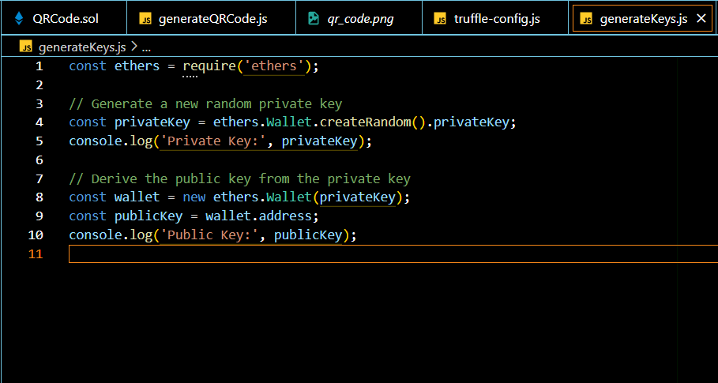
Fig 5.2 Private keys

Fig 5.3 product registration

Fig 5.5 ganache data

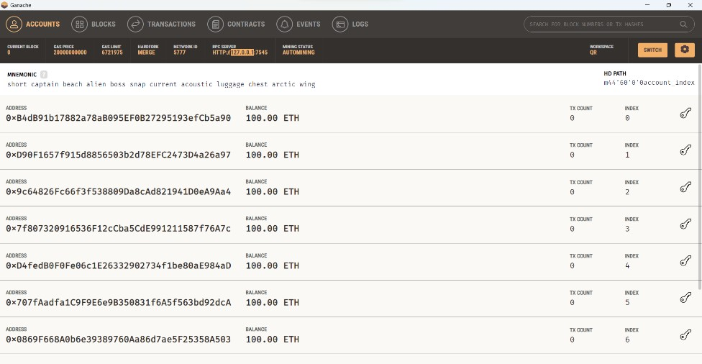

CHAPTER 6 CONCLUSION AND
FUTURE SCOPE

CONCLUSION

Verified & Secure: QR codes and blockchain ensure consumers get authentic GI- tagged products by linking them to secure tamper-proof data storage. Trustworthy Ecosystem: This system fosters trust in e-commerce for GI products by combating counterfeits and offering transparent verification.

Efficient & Accessible: User-friendly QR code scanning simplifies the verification process for consumers, eliminating complex procedures. Wider Impact: The success with GI products can pave the way for applying this system to verify other high-value or counterfeit-prone items across industries.

By leveraging the transparency, security, and immutability of blockchain technology, such a platform can ensure the authenticity and traceability of GI products, fostering greater consumer trust and protecting producers from counterfeit goods. The integration of blockchain with other emerging technologies like IoT will further enhance the platform’s capabilities, making product tracking more accurate and automated. As the demand for verified and high-quality products continues to rise, this innovative approach is poised to set new standards in the e-commerce industry, promoting a more secure, transparent, and efficient global marketplace for GI products.

Moreover, the transparency offered by blockchain ensures that every transaction and product journey is visible to all stakeholders, fostering trust and confidence among buyers and sellers. This creates a more secure and efficient marketplace for GI products, ultimately benefiting local producers and consumers alike.

The future of this technology promises not only to safeguard the heritage and quality of GI products but also to deliver substantial economic benefits to producers and unparalleled assurance to consumers.

    - Enhanced Transparency: Blockchain ensures that all product data, from origin to delivery, is recorded transparently, allowing consumers to verify authenticity easily.
    - Traceability and Security: The blockchain’s immutability provides an unalterable record of every product’s journey, enhancing trust in the quality and origins of GI products.
    - Smart Contracts for Automation: By automating transactions and delivery processes, smart contracts reduce reliance on intermediaries and minimize human error, ensuring smooth and reliable operations.
    - Dispute Resolution: A blockchain-backed system allows for quick and transparent resolution of any disputes, ensuring fair outcomes for both buyers and sellers.
    - Improved Trust and Consumer Confidence: The visibility and traceability of each transaction and product history increase consumer confidence in the authenticity and quality of GI products.
    - Support for Local Producers: The system empowers local artisans and producers by verifying the authenticity of their products, protecting their intellectual property, and increasing visibility in the global market.

FUTURE SCOPE

The future of a blockchain-enabled e-commerce platform for Geographical Indication (GI) products is highly promising, driven by the increasing demand for authenticity and transparency in the marketplace.

As consumers become more discerning and aware of the origins and quality of the products they purchase, the need for verifiable authenticity and traceability will

continue to grow. Blockchain technology offers a decentralized and immutable ledger that ensures each GI product’s provenance is securely recorded and easily accessible, fostering trust among consumers. The platform's ability to provide end- to-end traceability from production to sale will also benefit producers by protecting against counterfeiting and ensuring fair compensation for their high-quality, unique products.

Additionally, as blockchain technology matures, it will integrate more seamlessly with other emerging technologies such as IoT, enhancing the automation and accuracy of product tracking. In the long term, such platforms could revolutionize the e- commerce landscape by setting new standards for product verification, regulatory compliance, and consumer trust, ultimately leading to a more transparent, secure, and efficient global marketplace for GI products.

REFERENCES

- S. Nakamoto, “Bitcoin: a peer-to-peer electronic cash system,”2008,https://bitcoin.org/en/bitcoin-paper.

- V. Buterin, “A next-generation smart contract and decentralized application platform,” 2014,https://github.com/ ethereum/wiki/wiki/White-Paper.

- X. Yu, Y. Chu, F. Jiang, Y. Guo, and D. Gong, “SVMs classification based two- side cross domain collaborative filtering by inferring intrinsic user and item features,” Knowledge- Based Systems, vol. 141, pp. 80–91, 2018.

- UK Government Chief Scientific Adviser, “Distributed Ledger technology: beyond Blockchain,” 2016, https://assets. Publishing.service.gov.uk/government/uploads/system/uploads/ attachment_data/file/492972/gs-16-1-distributed-ledger-technology.pdf.

- X. Yu, Q. Hu, H. Li, J. Du, J. Gao, and L. Sun, “Cross-domain recommendation based onlatent factor alignment,” Neural Computing and Applications, vol. 14, 2021.

- Y. Yuan and F. Wang, “Blockchain: the state of the art and future trends,” Acta AutomaticaSinica, vol. 42, no. 4, pp. 481–494, 2016.

- J. Frizzo-Barker, P. A. Chow-White, P. R. Adams, J. Mentanko, D. Ha, and
S. Green,“Blockchain as a disruptive technology for business: a systematic review,” International Journal of Information Management, vol. 51, 2020.

- M. Usman, M. A. Jan, and A. Jolfaei, “SPEED: a deep learning assisted privacy- preservedframework for intelligent trans-portation systems,” IEEE Transactions on Intelligent Trans- portation Systems, vol. 3, pp. 1–9, 2020.

- R. Cole, M. Stevenson, and J. Aitken, “Blockchain technology: implications for operations and supply chain management,” Supply Chain Management: An International Journal, vol. 24,no. 4, pp. 469–483, 2019.

- N. Kshetri, “1 Blockchain’s roles in meeting key supply chain management objectives,”International Journal of Information Management, vol. 39, pp. 80–89, 2018.

- M. A. Jan, J. Cai, X. C. Gao et al., “Security and Blockchain convergence with Internet of Multimedia +ings: current trends, research challenges and future directions,” Journal of Network and Computer Applications, vol. 175, pp. 102918– 102935, 2021.

- Y. Chang, E. Iakovou, and W. Shi, “Blockchain in global supply chains and cross border trade: a critical synthesis of the state-of-the-art, challenges and opportunities,” International Journal of Production Research, vol. 58, no. 7, pp. 2082–2099, 2019.

- S. Fosso Wamba, A. Gunasekaran, R. Dubey, and E. W. T. Ngai, “Big data analytics in operations and supply chain management,” Annals of Operations Research, vol. 270, no.1-2,pp. 1-4, 2018.

- L.-W. Wong, L.-Y. Leong, J.-J. Hew, G. W.-H. Tan, and K.-B. Ooi, “Time to seize the digital evolution: adoption of Blockchain in operations and supply chain management among Malaysian SMEs,” International Journal of Information Management, vol. 52, 2020.

- P. Zhang, M. A. Walker, J. White, D. C. Schmidt, and G. Lenz, “Metrics for assessing Blockchain-based healthcare decentralized apps,” in Proceedings of the 2017 IEEE 19th

International Conference One-Health Networking, Applications and Services (Healthcom), pp.1–4, Dalian, China, October 2017.

45

1 | Name of the Student | R.Tejaswani U.Bindhiya E.Vindhya
2 | Email ID and Phone Number | 21951A05M6@iare.ac.in 9966881588  21951A05R0@iare.ac.in 8977621733  22955A0526@iare.ac.in 7396484186
3 | Roll Number | 21951A05M6  21951A05R0  22955A0526
4 | Date of submission
5 | Name of the Guide | Dr. Y MOHANA ROOPA
6 | Title of the project work/ research article | BLOCK CHAIN ENABLED E-COMMERCE FOR GI PRODUCTS
7 | Department | Computer Science and Engineering
8 | Details of the payment
9 | No. of times submitted | First / Second / Third  (First time – Free; Second time – Rs 200/-; Third – Rs 500/-;There after multiple of third)
10 | Similarity Content  (%) (up to 25%acceptable) | 1st | 2nd | 3rd | 4th
For R & D Centre Use
Date of plagiarism check
Similarity report percentage
R&D staff Name and Signature
I / We hereby declare that, the above mentioned research work is original & it doesn’t contain any plagiarized contents. The similarity index of this research work is……………..
Justification for similarity index:
………………………………………………………………...………………...…..…………………………
…………………………………………………………………………………………………………………
…………………………………………………………………………………………………………………
…………………………………………………………………………………………………………………
…………………………………………………………………………………………………………………
……………………………………………………………………………………………………...…………
……...………………...…………..

